- We want to add only the Annual Report section, wherein we will show only the current year report heading. We do not have any data or reports for previous years.
- OFFICE: 908, Akashdeep Building 26A Barakhamba Road New Delhi - 110001, India PHONE +91 83682 07840 EMAIL info@ibcc.co.in indobhutanchamber@gmail.com OFFICE HOURS Monday - Friday: 9:30 AM - 6:00 PM IST

- We want to add this in the ‘About Us’ section or wherever you feel it would be best to use.
India-Bhutan Relations
- Bilateral Trade: India has consistently been Bhutan’s top trading partner- both as an import source and as an export destination.
  - Since 2014, India’s trade with Bhutan has nearly quadrupled from USD 484 million in 2014-15 to USD 1744.44 million in 2024-25, accounting for about 80% of Bhutan’s overall trade.
- Cultural ties: Both countries share a common cultural heritage of Buddhism and have historical links dating back to the 8th century when a Buddhist monk, Padmasambhava, went from India to Bhutan and led the Nyingmapa sect of Buddhism.
- Development Partnership: Since Bhutan’s first Five Year Plan in 1961, India has closely partnered with Bhutan in its socio-economic development in line with the priorities of the people of Bhutan.
  - 71 Project Tied Assistance projects and 572 High Impact Community Development Projects have been agreed upon between the two sides and are under implementation.
- Connectivity: Railway links like Kokrajhar–Gelephu and Banarhat–Samtse are under active development to strengthen border and trade connectivity.
- Hydro-power cooperation: India has cooperated with Bhutan for the construction of five major hydro-electric projects in Bhutan totaling 2986 MW, including Chukha HEP (1988), Kurichhu HEP (2001), Tala HEP (2007-08), Mangdechhu HEP (2019) and Punatsangchhu-II HEP (2024).
- Space Cooperation: Both countries jointly inaugurated the Ground Earth Station of the South Asia Satellite (SAS) in Thimphu and launched India-Bhutan SAT, the first satellite jointly developed by India and Bhutan.
- Education and Capacity Building: Over 1000 scholarships are being provided annually by GoI for Bhutanese students to study in India. About 50,000 Indians are presently working in Bhutan in sectors such as infrastructure development, hydropower, education, trade and commerce, etc.
  - Under the Indian Technical and Economic Cooperation program (ITEC program), about 325 seats for training at world-class training institutions covering various fields are offered annually to Bhutan.

News

India and Bhutan hold 7th Joint Group of Customs (JGC) meeting in Munnar, Keralam, on 20th-21st April 2026
Posted On: 21 APR 2026 5:09PM by PIB Delhi
The 7th Joint Group of Customs (JGC) Meeting between India and Bhutan was held on 20th–21st April 2026 in Munnar, Kerala. The meeting was co-chaired by Mr. Yogendra Garg, Special Secretary and Member (Customs), Central Board of Indirect Taxes and Customs (CBIC), Government of India, and Mr. Sonam Jamtsho, Director General, Department of Revenue and Customs, Ministry of Finance, Royal Government of Bhutan.
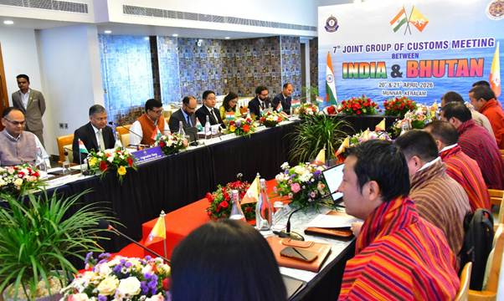
India and Bhutan share close and longstanding trade relations, with India being Bhutan’s largest trading partner, accounting for nearly 80% of Bhutan’s total trade. Bilateral trade between the two countries exceeded $1.9 billion in FY 2024–25, registering a growth of over 46% compared to the previous financial year.
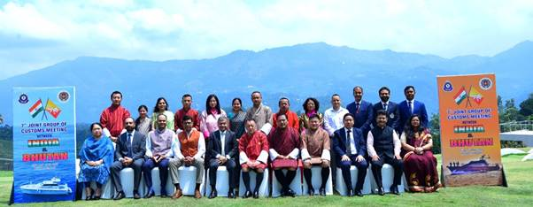
As part of the institutional framework for bilateral engagement, the JGC meetings serve as an important platform for addressing issues related to customs cooperation, trade facilitation, and border management. Given Bhutan’s landlocked geography, trade through land customs stations holds particular importance. Currently, there are 10 notified land customs stations along the India–Bhutan border, located in the states of West Bengal (6) and Assam (4).
During the meeting, both sides held detailed discussions on a range of priority areas, including Coordinated Border Management (CBM); Memorandum of Understanding (MoU) on pre-arrival exchange of customs data; strengthening of anti-smuggling mechanisms through intelligence sharing and enforcement cooperation; digitization of customs processes; and facilitation of transit cargo movement under the Electronic Cargo Tracking System (ECTS). The meeting also discussed and reviewed issues like improvement of border infrastructure, enhancing trade facilitation and harmonization & streamlining of customs procedures.
The Bhutanese delegation also visited the Kochi Port. The delegation was provided an overview of import and export procedures, including vessel berthing and container handling operations using gantry cranes. Bhutanese delegates were briefed about various aspects of maritime enforcement, such as sea patrolling, identification of suspicious vessels, rummaging operations, communication systems used during patrols, such as satellite phones and the Automatic Identification System (AIS) and methods for identification of suspicious cargo and the procedures for its examination.
The meeting concluded on a positive note, with both sides reaffirming their shared commitment to further strengthening customs cooperation, promoting seamless cross-border trade, and ensuring secure and efficient border management under the framework of the Agreement on Trade, Commerce and Transit.

Ministry of Power
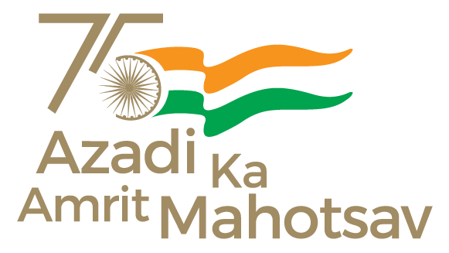

Union Minister Shri Manohar Lal Visits Punatsangchhu Hydropower Projects; Participates in Key Milestone Ceremony
Posted On: 10 APR 2026 4:21PM by PIB Delhi
The Union Minister of Power and Housing & Urban Affairs, Shri Manohar Lal, on the second day of his visit to Bhutan, visited to the Punatsangchhu-I and Punatsangchhu-II Hydropower Project sites.
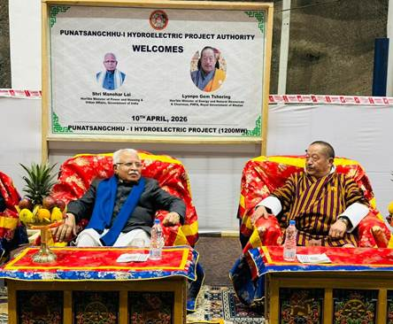
At the Punatsangchhu-I project site, the Union Minister attended the ceremony for pour of concrete of the dam, marking a significant milestone in the development of the project. The project, the largest joint hydropower venture between the two countries, is expected to enhance Bhutan’s hydropower capacity substantially upon completion.
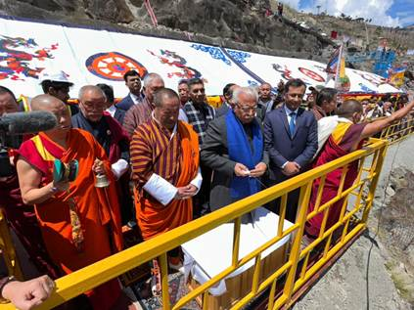
During the visit, Shri Manohar Lal emphasized the long-standing partnership in the energy sector, noted India’s continued support including financial assistance and technical collaboration, and commended the coordinated efforts of engineers and experts from both sides in advancing the project safely and efficiently. He also inspected the powerhouse and was briefed on the status of implementation and key milestones achieved.
Shri Manohar Lal then visited the Punatsangchhu-II project, which was jointly inaugurated on 11 November 2025 by Shri Narendra Modi, the Prime Minister of India, and His Majesty Jigme Khesar Namgyel Wangchuck, has since emerged as a significant contributor to Bhutan’s energy sector.
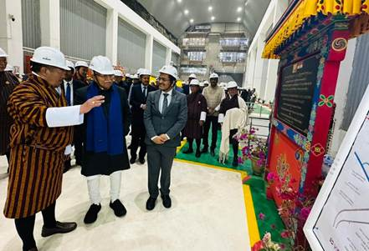
The Union Minister reviewed the operational performance of the project, noting that it has already generated substantial electricity and revenue while enabling exports of clean power to India. He appreciated the successful execution and operational efficiency of the project, acknowledged its contribution to Bhutan’s economic growth, and reaffirmed India’s continued commitment to supporting Bhutan in sustainable energy development. The visit included inspection of the powerhouse and dam site, where he was apprised of ongoing operations.
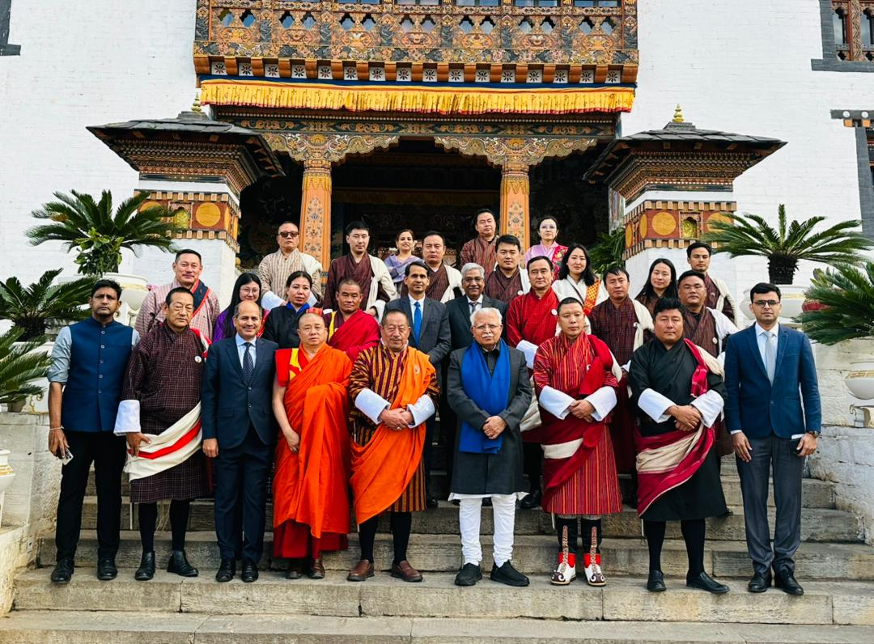
Shri Manohar Lal also visited the Wangdue Phodrang Dzong, which is a repository of Bhutan’s rich historical and cultural heritage.
*****

Bhutan-India Trade Relations
The Government of India has been associated with Bhutan’s planned development since the start of planned development when the first five-year plan was launched in 1961 and continues to be our main development partner. The mutually beneficial economic ties have been the centrepiece of the Bhutan-India relations. Currently, India is not only Bhutan’s main development partner, but also its leading trade partner.
There has been a free trade and commerce between the territories of India and Bhutan since the signing of the Treaty between the Government of India (GoI) and the Royal Government of Bhutan (RGoB) in 1949. However, the first formal Agreement on Trade and Commerce between GoI and RGoB was signed in 1972 which has undergone five revisions till date (1983, 1990, 1995, 2006 and 2016). The current Agreement on Trade, Commerce and Transit between the Royal Government of Bhutan and the Government of the Republic of Indiais valid till 2026.
The objective of the Free Trade Agreement (FTA) is to further strengthen the age-old ties and enhance bilateral trade and economic cooperation for mutual benefit and development of the two countries.
The most important features of the Free Trade Agreement are the provision for free trade between the two countries and transit rights for Bhutan’s trade with Third countries. The rapid growth of trade between the two countries is attributed to the free trade arrangement which allows free flow of goods into each other’s territory without any import duty. In addition, the transit right granted through the FTA enables Bhutan to trade with the rest of the world. Bhutan has been able to improve upon these provisions through the successive renewal of the Agreement with addition of new entry and exit points in India for Bhutan’s external trade. The progressive changes made in the scope of the Agreement is reflective of the economic and political progress that Bhutan has achieved over the past decades. The FTA has been very instrumental not just in expanding trade with India but also in facilitating Bhutan’s trade diversification with other trading partners.
India has been the largest and the most important trading partner for Bhutan since the start of the development plans. In 2020, overall trade with India was recorded at Nu. 94.89 billion (including electricity), which accounted for 82% of Bhutan’s total external trade and the figure without including electricity was recorded at Nu. 67.18 billion, which accounted for 77% of Bhutan’s total trade. The overall import from India accounted for 87% of the total import value with or without taking into account trade in electricity. Exports to India accounts for 90% of total exports including electricity and 77% without electricity.
Major Export Goods:
Bhutan’s major exports to India includes electricity, ferro-silicon, dolomite, semi-finished product of iron or non-alloy steel, Portland pozzalana cement, cardamoms, pebbles gravel, gypsum, carbide of silicon, ordinary Portland cement, etc. The total export value in 2020 including electricity was Nu.43.51 billion and excluding electricity was Nu.27.52 billion.
Major import Goods:
Bhutan’s major imports from India comprise of diesel, petrol, motor vehicles for transport of goods(dumper), ferrous products, telephones, electrical distribution panel board, coke and semi-coke, soya-bean oil, passenger cars and, petroleum bitumen. The total imports from India including electricity was Nu.51.37 billion.
Future prospects:
With the most liberal trading arrangement accorded by the FTA, India is certain to remain as the most important trading partner for Bhutan. The government, therefore, remains steadfast to maintain continued bilateral trade talks to build upon the existing trade relations. The annual bilateral meeting on Trade, Commerce and Transit between GoI and RGoB at Commerce Secretary level (CSLM) has not only been effective in finding appropriate solutions to trade and transit issues hindering bilateral trade, but it has also provided in itself a dedicated forum to explore new avenues for expanding trade and commerce between the two countries.
In view of the close ties of friendship between the two Governments and its people, bilateral trade with India is envisaged to be very instrumental in elevating socio-economic relations to new heights.

